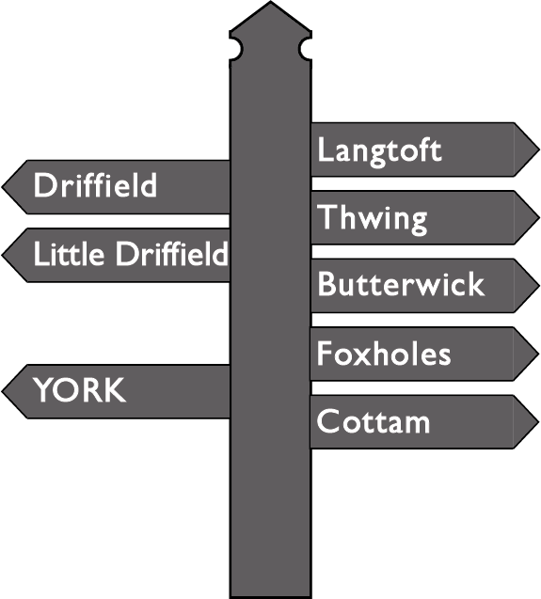

An Order for Evening Prayer
Eve of Ascension Day and
Ascension Day

Preparation

O God, make speed to save us.
All O Lord, make haste to help us.

Your throne has been established from of old;
All you are from everlasting. Alleluia.

Blessed are you, creator God,
to you be glory and praise for ever.
From the darkness of death you have raised your Christ
to the right hand of your majesty on high.
The pioneer of our faith, his passion accomplished,
has opened for us the way to heaven
and sends on us the promised Spirit.
May we be ready to follow the Way
and so be brought to the glory of his presence
where songs of triumph for ever sound:
Blessed be God, Father, Son and Holy Spirit.
All Blessed be God for ever.

This opening prayer may be said

That this evening may be holy, good and peaceful,
let us pray with one heart and mind.

Silence is kept.

As our evening prayer rises before you, O God,
so may your mercy come down upon us
to cleanse our hearts
and set us free to sing your praise
now and for ever.
All Amen.

The Word of God

Psalmody
The appointed psalmody is said.

Each psalm or group of psalms may end with
All Glory to the Father and to the Son
and to the Holy Spirit;
as it was in the beginning is now
and shall be for ever. Amen.

If there are two Scripture readings, the first may be read here, or both may be read after the canticle.

Canticle
All God raised Christ from the dead,
the Lamb without spot or stain. Alleluia.
All Christ was believed in throughout the world
and taken up in glory.

1 Christ Jesus was revealed in the flesh •
and vindicated in the spirit.

2 He was seen by angels •
and proclaimed among the nations.

3 Believed in throughout the world, •
he was taken up in glory.

4 This will be made manifest at the proper time •
by the blessed and only Sovereign,

5 Who alone has immortality, •
and dwells in unapproachable light.
All To the King of kings and Lord of lords •
be honour and eternal dominion. Amen.
1 Timothy 3.16; 6.15,16

All Christ was believed in throughout the world
and taken up in glory.

Scripture Reading

One or more readings appointed for the day are read.

The reading(s) may be followed by a time of silence.

A suitable song or chant, or a responsory in this or another form, may follow

Sing to the Lord and bless his name;
All tell out his salvation from day to day.
God has gone up with a merry noise;
All sing to the Lord and bless his name.
The Lord with the sound of the trumpet:
All tell out his salvation from day to day.
He has led captivity captive,
and given gifts to his people.
All Sing to the Lord and bless his name;
tell out his salvation from day to day.
from Psalms 47and 68

Gospel Canticle

Refrain for Eve of Ascension Day:
All Christ was believed in throughout the world
and taken up in glory. Alleluia.

(or)

Refrain for Ascension Day:
All I have made your name known to those you have given me;
and now I pray for them, for I am coming to you. Alleluia.
1 My soul proclaims the greatness of the Lord,
my spirit rejoices in God my Saviour; •
he has looked with favour on his lowly servant.
2 From this day all generations will call me blessed; •
the Almighty has done great things for me
and holy is his name.
3 He has mercy on those who fear him, •
from generation to generation.
4 He has shown strength with his arm •
and has scattered the proud in their conceit,
5 Casting down the mighty from their thrones •
and lifting up the lowly.
6 He has filled the hungry with good things •
and sent the rich away empty.
7 He has come to the aid of his servant Israel, •
to remember his promise of mercy,
8 The promise made to our ancestors, •
to Abraham and his children for ever.
Luke 1.46-55
All Glory to the Father and to the Son
and to the Holy Spirit;
as it was in the beginning is now
and shall be for ever. Amen.
Refrain for Eve of Ascension Day:
All Christ was believed in throughout the world
and taken up in glory. Alleluia.

(or)

Refrain for Ascension Day:
All I have made your name known to those you have given me;
and now I pray for them, for I am coming to you. Alleluia.

Prayers

Thanksgiving may be made for the day.

Intercessions are offered
¶ for peace
¶ for individuals and their needs

This cycle and this prayer may be used.

These responses may be used

Lord, in your mercy
All hear our prayer.

(or)

Lord, hear us.
All Lord, graciously hear us.

Silence may be kept.

The Collect of the day or the following is said

Grant, we pray, almighty God,
that as we believe your only-begotten Son our Lord Jesus Christ
to have ascended into the heavens,
so we in heart and mind may also ascend
and with him continually dwell;
who is alive and reigns with you,
in the unity of the Holy Spirit,
one God, now and for ever.
All Amen.

The Lord's Prayer is said
Looking for the coming of his kingdom,
let us pray with confidence as our Saviour has taught us
All Our Father, who art in heaven,
hallowed be thy name;
thy kingdom come;
thy will be done;
on earth as it is in heaven.
Give us this day our daily bread.
And forgive us our trespasses,
as we forgive those who trespass against us.
And lead us not into temptation;
but deliver us from evil.
For thine is the kingdom,
the power and the glory,
for ever and ever.
Amen.

The Conclusion

May Christ, who has opened the kingdom of heaven,
bring us to reign with him in glory.
All Amen.

Let us bless the Lord. Alleluia, alleluia.
All Thanks be to God. Alleluia, alleluia.

